Diary notes from an internship…

“It ‘hit me’ just the right way…”

“I was welcomed to the Volunteer House by Peter. We arranged it together so that I was to help some of the girls from Somalia with their homework. I was very excited about it all. Would the kids be all right? Would the other volunteers share my vision for this kind of work? Or would it all come down to coffee and cigarettes on the sidewalk outside the building?
Very quickly I was placed at a table together with a Somali mother and her two girls from the 1st and the 3rd grade. The mother never went to school; yet she has four girls, whom she takes to ‘homework café’ everyday here in the Volunteer House. The girls were very polite…they thanked me gratuitously and asked if I would be back again… they smiled and were very kind… the whole atmosphere of the Volunteer House was very lovely. And no… there were no coffee or cigarettes on the sidewalk.
I told Peter, I would come down again next week. My perspective was widened, my prejudices were undermined, and I got wiser, happier and was doubtlessly very useful.”

“Yet another one of those great days…”

“Three hours in the Volunteer House on a Wednesday afternoon with all the young people. There were mainly Somali and Ethiopian kids present when I have been there, which means I have gotten a dozen new younger friends in town. Big boys, whom I would usually say looks like bandits, and girls whom I have usually felt a bit sorry for. But I must say, they are so incredibly nice, lovely and easy-going.”

Plan your Encore
A new course program for senior employees 60+
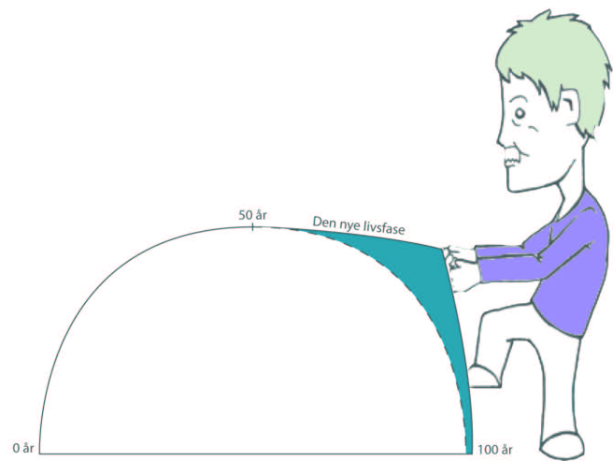
Life after work
Retiring from work can be one of the hardest transitions in our lives. How do we position ourselves in life and society when we do not have a job designation? Where and how do we regain the aspects of our working life we used to love? And how does one rebuild an encore career in such a way as to keep it occupied with passionate activities? Questions like these will be our starting point in this course program for employees 60+.

Say hello to your encore career
In collaboration with the local volunteer organization the company A Third Career offers a course program for 20 senior employees. The course program runs 37 hours spread over three months. Participating is free.

The new phase of life – ‘full-grown’ before growing old
The aim of the course is to make seniors better prepared to tackle the challenges that come with the transition from working life to retirement. Compared with the past, seniors of today have received a new ‘life bonus’ of 25 years; many being at the ‘top of their game’ in the retirement age, postponing old age and dependency on others significantly. Hence, we need a new, more meaningful and up-to-date version of the role of the generation called the ‘baby boomers’.

The course program – seminars and internships
The course program aims to make the participants more aware of how to continue a life filled with joyful and motivating activities, while contributing to society’s welfare with the invaluable experience from a long life. Thus the course will be split into two entities, the first part being a series of seminars, the second one inviting you to join the world of volunteer work.

(1) Seminars – finding your own way
These seminars will challenge the preconceptions most of us have of getting older by looking closely at the cultural norms that exist, and not least how they can create barriers for individual wishes and ideas for a new life in the third age. Through presentations, group exercises and discussions we will pave the way for a better planning and awareness of how to cease the change and balance the wishes for life on the home front with possibilities of being a part of a new working community. This part of the course program will take up half of the appointed time.

(2) Internships – meet the world of volunteering
Giving something to someone is a joy – for that someone and also for you. This is what volunteering is about. This part of the course program offers you to try out – before you retire – what volunteering would be like (three hours a week for six-seven weeks). Choosing what you would like to volunteer as, you get the chance to try it and meet what might be future colleagues.

PROGRAM:

One-day seminar: Finding your own guiding principles as a senior and
pinning down each individual’s capabilities and strong points.

Seminar, half the day: Appointing interests in volunteer internships
and clarifying the possibilities of each individual.

Internships: Visiting voluntary organizations and setting up internships

Internships: Max. 20 hours: 3-4- hours a week spread over six weeks

Seminar, half the day: Evaluating experiences of the internship and
the whole course program.

Conditions for participation:
Having turned 60 you can register, as long as seats are available.
You can choose to locate your internship close to work or close to your
home – that is up to you.
Participation is free and the internship is regarded as regular working
hours with pay. Of course, it should be said that one is by no means
obligated to volunteer after the last day on the job.

Manager and conductor of the course program is Poul-Erik Tindbæk, holding several years of experience with guidance on the field of retirement transitions. If you wish further information go to: www.en3karriere.dk or contact Poul-Erik at pet@en3karriere.dk /+45 29612883

